

**COAL**

**(Lab)**

**Task 1**

**Name:** Abdullah Ahmed

**SAP ID:** 53639

**Semester:** 3rd

**Q1: Multiply numbers using variables and store the result in variables.**

.model small

.stack 100h

.data

var1 db 2 ; variable 1 with value 2

var2 db 2 ; variable 2 with value 2

var3 db 3 ; variable 3 with value 3

result dw ? ; Define a word (16-bit) to store the multiplication result

.code

main proc

mov ax, @data

mov ds, ax

; Load var1 into AX

mov al, var1

; Multiply var1 by var2

mov bl, var2

mul bl

; Now multiply the result by var3

mov bl, var3

mul bl

; Store the result in the result variable

mov result, ax

; Exit program syntax

mov ah, 4Ch

int 21h

main endp

end main

**Q2: Write assembly code to swap two numbers using variables. Screenshot of the variables before and after swap should be attached.**

.model small

.stack 100h

.data

num1 db 5 ;first number

num2 db 8 ;second number

.code

main proc

mov ax, @data

mov ds, ax

; Load num1 into AL register

mov al, num1

; Load num2 into BL register

mov bl, num2

;swapping values

mov cl, bl

mov bl, al

mov al, cl

; Store the swapped values back into variables

mov num1, al

mov num2, bl

; Exit program

mov ah, 4Ch

int 21h

main endp

end main

**Before Swapping**

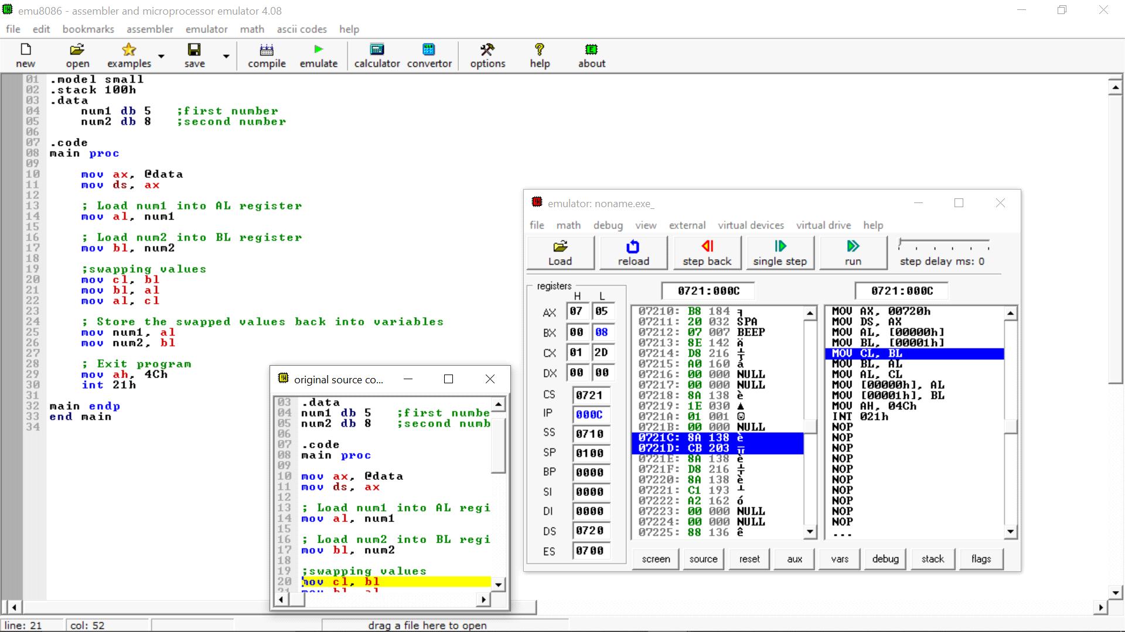

**After Swapping**

